NATURAL PRECIOUS METALS cc

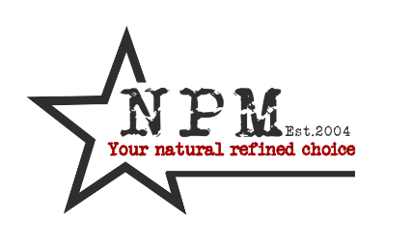

**POLICY: LEGAL COMPLIANCE**

|  |  |  |  |
| --- | --- | --- | --- |
| VERSION NUMBER | REVIEWERS DATE | NEXT REVIEW | REVISION DETAILS |
| 1 | 22/Oct/2014 | SEPT 2015 | Nikki Pavlakis |
|  |  |  |  |
|  |  |  |  |

**PURPOSE**

This policy is to ensure that Natural precious Metals follows relevant laws, regulations and business rules. There are two requirements for Natural Precious Metals to be compliant with the law, first its policies need to be consistent with the law. Second, its policies need to be complete with respect to the law.

**POLICY STATEMENT**

Natural Precious Metals is committed to ensuring compliance with:

* All applicable legal and regulatory obligations; Our own core policies; and Our contractual obligations with third parties.

**SCOPE**

This policy applies to all relevant members at every level. Natural Precious Metals respects applicable law, including international law, and requires its employees and business partners to do likewise.

**GENERAL PRINCIPALS**

Failure to understand and act within appropriate legal boundaries can result in a number of negative consequences, including customer dissatisfaction, ineffective allocation of resources, missed business opportunities, failed business ventures, negative publicity, penalties and damages, litigation and the potential loss of customers.

This Policy will be managed by the Managing Director and the Compliance Officer. The Compliance Officer will be responsible for ensuring that Natural Precious Metals staff are given appropriate information and training to assist them to comply with legal, regulatory and policy obligations All Natural Precious Metals employees are accountable for ensuring they understand and use relevant processes and tools (including training) to ensure compliance and adherence to all applicable laws.

**COMPLIANCE LAWS & ACTS**

Natural Precious Metals have identified the following Laws as being applicable to its activities and is fully committed to compliance to them. All these are embodied in various SA legislation documentation.

* Bribery and facilitation payments
* Money Laundering and finance of terrorism
* Corruption, smuggling, embezzlement, fraud, racketeering, transfer pricing and tax evasion
* Trading practices and consumer rights
* Human Rights
* Child Labour
* Employment terms and conditions
* Occupational Health & Safety Environmental Management
* Community and Social Impact Consumer Health safety and environmental information
* Competition Laws

The Organization will stay up to date with all relevant Acts and communicate any relevant changes to employees. Natural Precious Metals makes use of a consultants Pinnacle SHEQ Consultants for legal updates and evaluation of compliance audits. These acts will include:

* Employment Tax Incentive Act Financial Intelligence Centre Act
* Income Tax Act National Credit Act Statistics SA Act Value Added Tax Act
* Basic Conditions of Employment Act
* Compensation of occupational injuries & diseases Act
* Employment Equity Act
* Labour Relations Act Occupational Health & Safety Act
* Skills Development Act
* Unemployment Insurance Act
* Disaster Management Act
* Protection for Harassment Act
* 2nd Hand Goods Act
* Older Persons Act BBBEE Act
* Companies Act
* Consumer Protection Act
* Counterfeit Goods Act
* National Environmental Act
* Management National Environmental Waste Act

It is the employee’s responsibility to contact management should he / she have any queries. Employees are invited to comment on this policy and suggest ways in which it might be improved. Comments, suggestions and queries should be addressed to line Management.